## Executive Summary & Company Description

Hey there, dear reader! When you come across text in the lovely shade of Sky Blue, consider it to be focus highlights. It'll help us keep our attention on the important stuff

There are several problems currently faced by international companies/financial institutions:

1. Lack of interoperability between different payment systems
2. Slow and costly cross-border transactions
3. High volatility and risk associated with traditional currency exchange
4. Limited access to banking services for the unbanked entities in emerging economies
5. Lack of transparency and accountability in traditional financial systems
6. Correspondent bank inefficiencies

SFSP[1] aims to solve the problems stated above by providing a state-of-the-art platform that leverages blockchain technology's speed, security, and efficiency to provide fast and cost-effective cross-border transactions. Our innovative platform will be built on the SUI blockchain network and will draw inspiration from a number of successful models (be those of Ripple, Strike or Stellar) to deliver a user-friendly experience no matter the location.

Product:

1. Accessible APIs/Platform
   1. Customer Support
   2. Blockchain-enabled SafetyImmutabilityTransparencySpeed
2. Participant network
   1. Native user authentication
   2. Smart contract presets
3. Customer Support

Mission: building affordable and scalable solutions for financial institutions to become truly digital

Vision: make wholesale transactions safe, free of barriers and efficient

Our main customer targets are:

1. Other PSPs (payment service providers)
2. Banking institutions
3. International companies with large volume of treasury operations
4. Supraorganisational entities (e.g., associations)
5. Government-related entities

The marketing strategy in the meantime will materialise via digital marketing partnerships and participation in industry events. Digital marketing efforts will utilize social media, search engine advertising, and thought leadership content[2] to showcase expertise and platform benefits. Strategic partnerships with tech companies and financial institutions will be pursued to expand reach and accelerate adoption[3]. Participation in industry events will facilitate networking, platform showcasing, and staying up-to-date with industry trends. The sales strategy will focus on building relationships understanding customer needs providing customised solutions. The platform's native support of OpenID Connect will be highlighted to attract regulated institutions, while the elimination of prefunded accounts will be emphasized to showcase the platform's efficiency and cost-effectiveness.

Our projected revenues of $32.13M over the next three years will be generated through a subscription fee for integration into clients' architecture, recurring fee for being in the network, and transaction fees. We also anticipate building a large network of financial institutions to ensure a steady and growing volume of transactions.

To bring this business plan to life, we will require initial funding of $1M to cover development, legal and regulatory compliance, marketing, and initial operational costs for the first year. For the next 2 years, we will need $4.4M more to cover operational and marketing costs. We are seeking investors who share our vision for disrupting the cross-border payments industry and are committed to building a sustainable and profitable business.



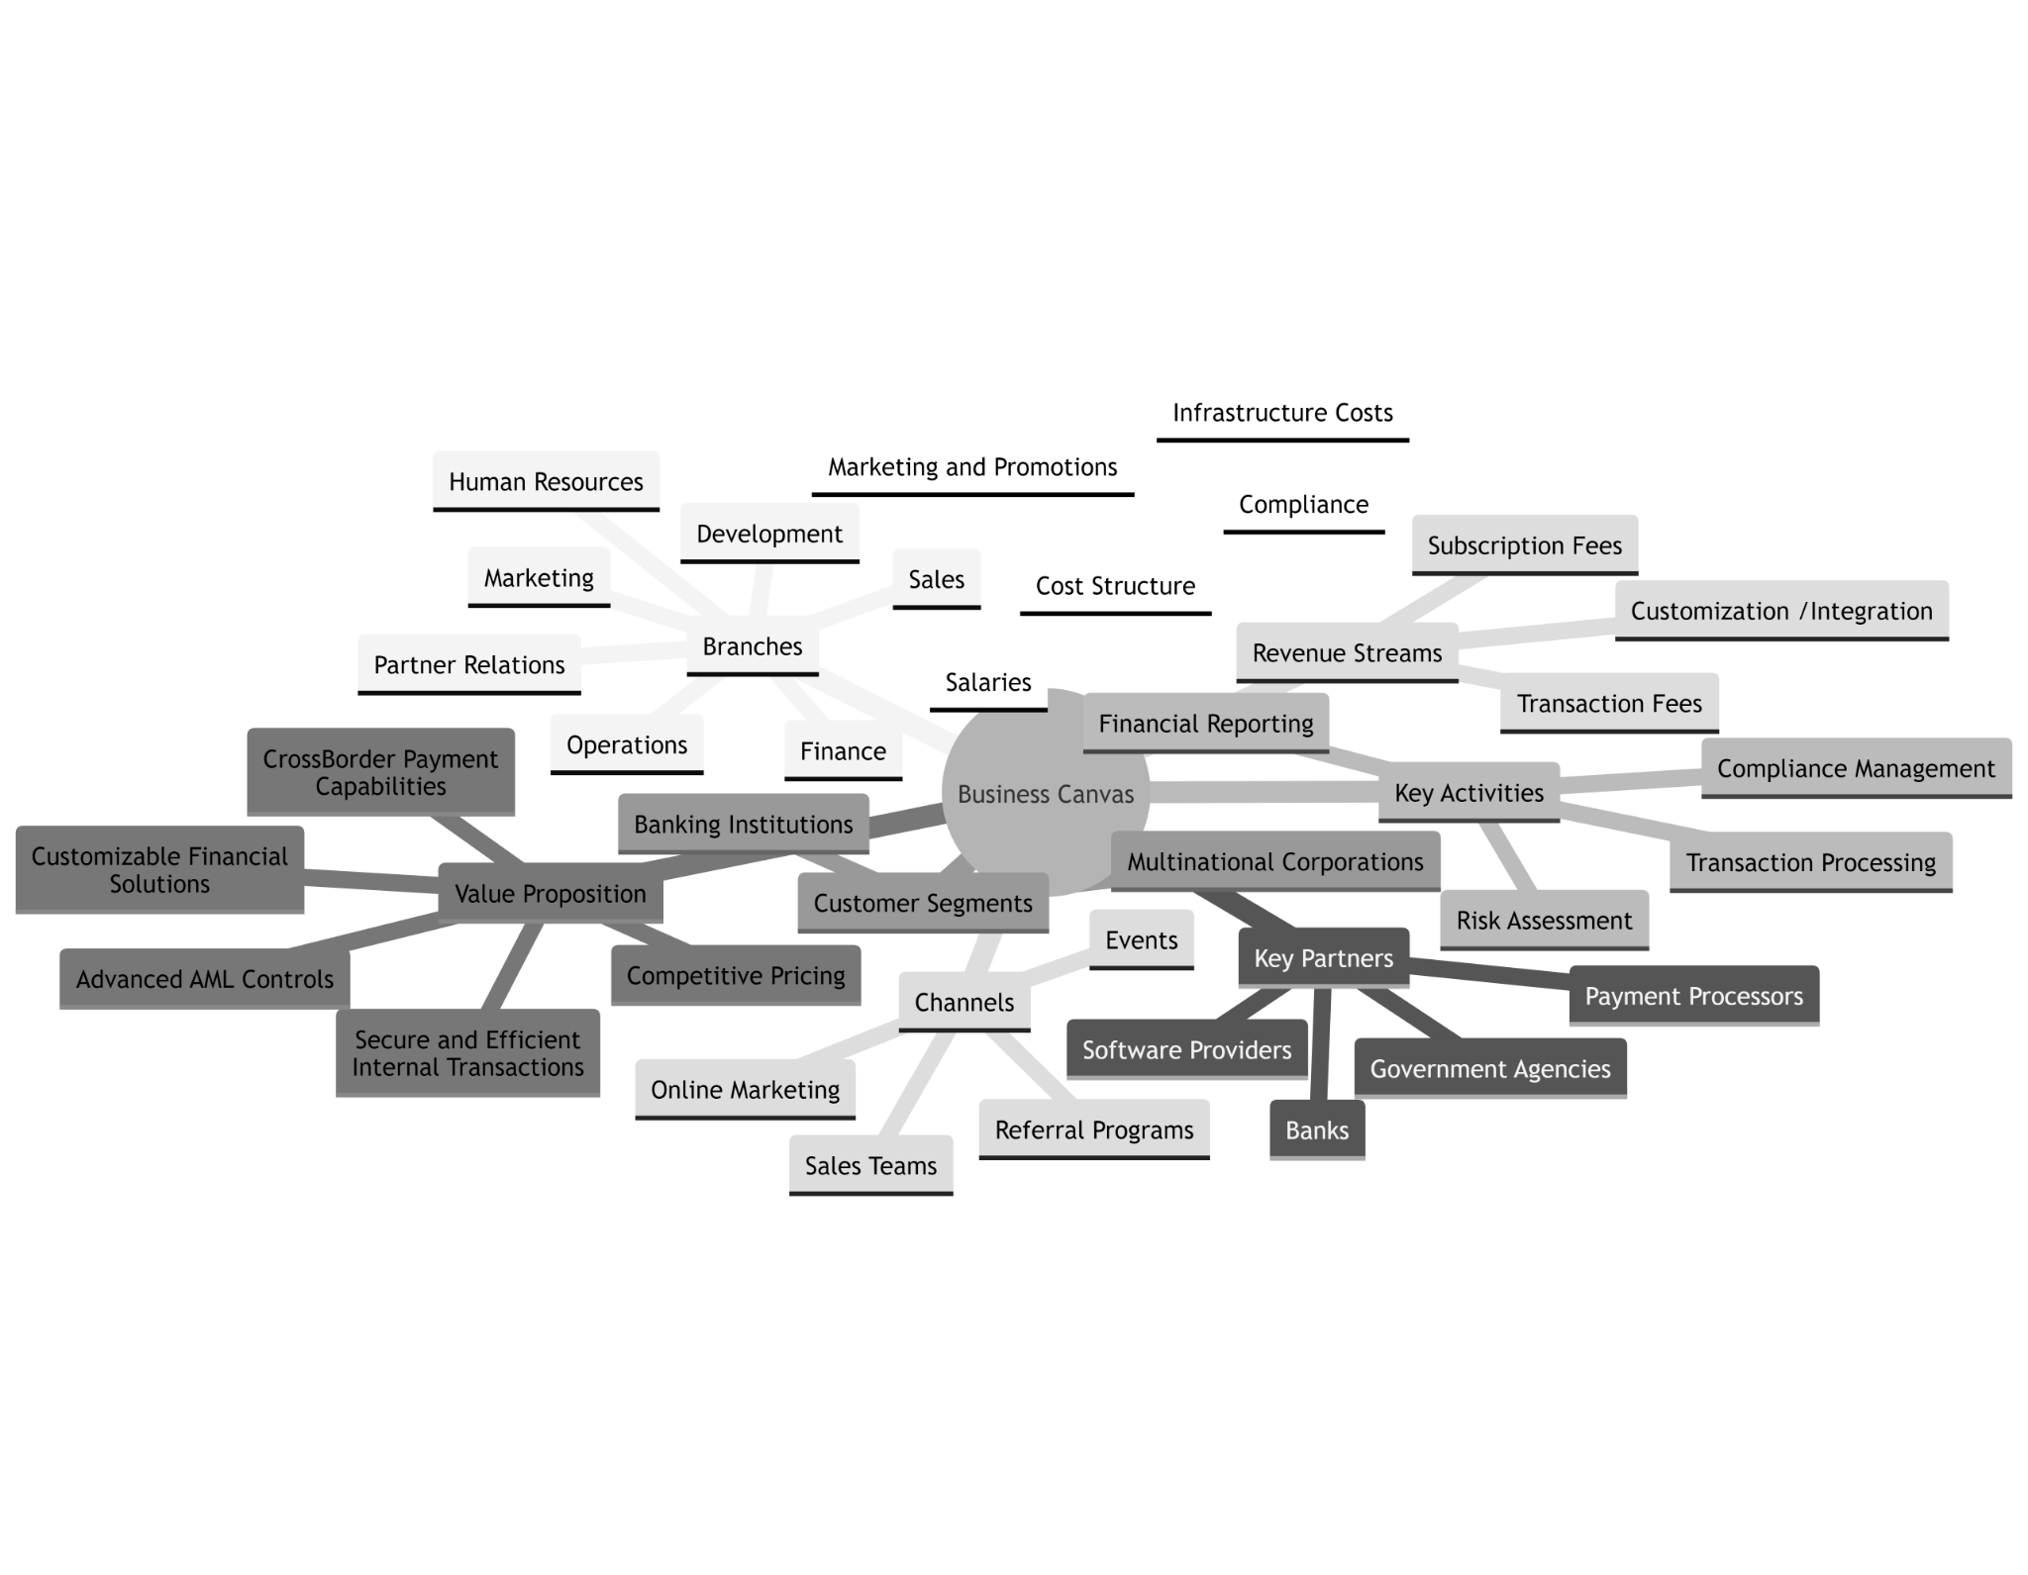

## Market Analysis

Industries associated with blockchain have undergone significant turmoil in recent years, resulting in regulatory scrutiny and consumer losses. This has led to a healthy skepticism among consumers and businesses, which has shifted the focus towards real companies and technologies that solve genuine customer pain points. Despite the regulatory risks associated with blockchain payments technology, many businesses see its potential to streamline cross-border payments. Blockchain technology has already delivered on reducing the cost and increasing the speed of moving funds, as well as increasing transparency. One expects that the readers at least heard about quite successful mobile banks/remittance companies like Azimo or Revolut which use such technology for wholesale transactions. The adoption of crypto has extended beyond remittance companies, as large corporations turn to it for payroll,inter-venue transfers or paying suppliers. One does not have to remind the reader that any considerable organisation has a number of affiliated entities.

The payments industry is poised for significant growth in the coming years, driven by technological advancements and changing consumer preferences. The global digital payments market is projected to reach $168 trillion by 2027[4], with a compound annual growth rate of 17.6% from 2020 to 2027 (alternative [data](https://www.mordorintelligence.com/industry-reports/global-payments-market))

The cross-border payments segment represents a significant share of the payments market, with a projected market size of $27.5 trillion by 2026[5] (16.4% of the previous metric). Nonetheless, the current cross-border payments landscape faces challenges such as slow transaction times, high fees, and limited accessibility, particularly in emerging markets. These market challenges present a significant opportunity for the new generation of PSPs, such as ours, to disrupt the market and offer faster, cheaper, and more accessible cross-border payment solutions.

| Issues of Current Infrastructure   1. Costly Transactions[6] 2. Multiple Intermediaries (correspondent banks, exchanges) 3. Delayed Settlement (3-5 days) 4. Little Transparency (one-way messaging) 5. Errors (5% rate) |
| --- |

Our cross-border payment platform, based on the SUI blockchain network, is expected to be uniquely positioned to address these market challenges by offering instant and low-cost cross-border transactions (especially for emerging economies which are loosely targeted by new solutions). The blockchain-based infrastructure provides unparalleled security and transparency, while the lightning-fast transaction speeds ensure that our customers can send and receive payments in real-time.

We anticipate that our platform will appeal to a broad range of customers, particularly financial institutions that require fast and secure cross-border payment services. Our platform natively supports OpenID Connect[7], a key feature that will be particularly useful for regulated institutions, enabling them to comply with various regulations while offering a seamless user experience enabled by blockchain. To provide context, authorisation in current blockchain-based solutions is either ensured on the software layer (not engraved in the blockchain) or added through subchains.

Financial institutions are currently grappling with the challenge of managing pre funded accounts, which can be costly and time-consuming. Our platform solves this problem by providing direct access to liquidity[8] through our network of liquidity providers, enabling financial institutions to send and receive payments instantly without having to manage pre funded accounts. Additionally, the trend towards cashless payments is expected to continue, as consumers increasingly prefer the convenience and safety of digital payments. This shift towards digital payments is especially prevalent in emerging markets, where the use of cash is declining rapidly. Our platform's low transaction fees and accessibility to emerging markets position us well to capitalize on this trend.

To add to it, the COVID-19 pandemic has accelerated the adoption of digital payments as people seek contactless payment options. As the pandemic recedes and economies recover, the shift towards digital payments is expected to persist, presenting a favorable market environment for our platform.

The implementation of a new platform/service to aid banks in completing mutual settlements has selected Europe, United Kingdom, Dubai, and South America as target markets for several reasons.

1. Europe is home to some of the largest financial centers globally, including London, Frankfurt, and Paris. These cities act as hubs for global financial transactions, and the banking systems in these regions handle high volumes of cross-border transactions. By implementing the new platform in Europe, the opportunity arises to streamline and automate these processes, resulting in faster and more efficient settlements.
2. United Kingdom has a long-standing tradition of financial innovation, and its banking system is one of the most advanced worldwide (Open Banking was first introduced there). Implementing the new platform in the UK would provide a testbed for new technologies and processes, and the country's large financial sector would serve as a launchpad for wider adoption worldwide.
3. Dubai has become a significant financial center in the Middle East, with a growing number of banks and financial institutions operating in the region. Implementing the new platform in Dubai would serve as a gateway to the wider Middle East region and provide an opportunity to tap into the growing demand for efficient financial services.
4. South America is a region with diverse economies and financial systems, with countries such as Brazil, Argentina, and Chile having significant banking sectors. Implementing the new platform in South America would provide an opportunity to bring greater efficiency and automation to these markets and help foster economic growth in the region.
5. Additionally, all the regions mentioned have large, stable, and developed banking systems with a high number of banks:
6. Europe has 5171 banking institutions
7. The UK has 357 banking institutions
8. Dubai has 51 banking institutions
9. South America has 801 banking institutions

Therefore, the total amount of banks in all the regions listed above equals 6380. The tree diagram below shows the estimated number of banks that are expected to subscribe to the platform in the first 3 years of the project.



## 

## 

## 

## Products and Services

Our company will aim to provide efficient, secure, and cost-effective cross-border payment solutions to individuals and businesses worldwide. We will achieve this through our platform, which will offer a range of products and services, including:

1. Transaction Speed: Our platform will leverage the speed and security of the SUI blockchain network to provide customers with instant cross-border payment solutions. Transactions will be processed in real-time, enabling faster and more efficient cross-border payments.
2. Transaction Cost: We recognize that traditional cross-border payment providers charge high fees, which can be a barrier to individuals and businesses of all sizes, particularly in emerging markets. Our platform will offer significantly lower fees, making our solutions accessible to a broader range of customers.
3. Transaction Security: Our platform will ensure unparalleled security and transparency, using the SUI blockchain network to record transactions on a public blockchain. This will maintain the innovation loop and increase client confidence and trust in the payment process.
4. User-friendly Interface: Our platform will be designed with a user-friendly interface, making it easy for customers to initiate and track their transactions. In addition, established companies favour simplicity at least due to regulatory burdens on their shoulders.
5. Customised Solutions: We understand that businesses may require specialized cross-border payment solutions. As such, we will work closely with our business customers to understand their specific needs and provide tailored solutions that meet their requirements (including the customised currencies mentioned above). Most importantly, customers with established connections and appropriate initiatives will be given a chance to automate (including programmability enabled by smart contracts and making transactions effective) certain aspects.
6. API Integrations: Our platform will offer API integration, allowing businesses to seamlessly integrate our cross-border payment solutions directly into their existing systems (which tend to be quite complex and custom in banks). This will streamline their payment processes and reduce the complexity associated with cross-border payments.

### Perceived Benefits from Layer-1[9]:

1. Horizontal Scalability: SUI offers horizontal scalability, which enables the network to handle a large number of transactions, making it ideal for processing cross-border payments.
2. Object-centric Design: SUI's object-centric design allows developers to define, create, and manage programmable objects that represent user-level assets, providing greater flexibility and customization.
3. Programmable Tx Blocks: SUI's programmable transaction blocks allow for more complex transactions, making it easier to handle cross-border payments that may involve multiple accounts and currencies.
4. SUI Move: SUI Move is a programming language that allows developers to create smart contracts for the SUI network, enabling them to build custom payment solutions.
5. Sponsored Transactions: SUI's sponsored transactions feature allows applications to pay gas fees on behalf of users, removing a significant barrier to completing transactions.
6. Advanced Cryptography: SUI uses advanced cryptography techniques to ensure the highest levels of security on the network, which is essential for cross-border payments.
7. Zero-knowledge Proofs: Engraved into the blockchain, they can help protect user privacy and improve the security of cross-border payments by avoiding the disclosure of sensitive payment information and ensuring faster, streamlined transaction validation.



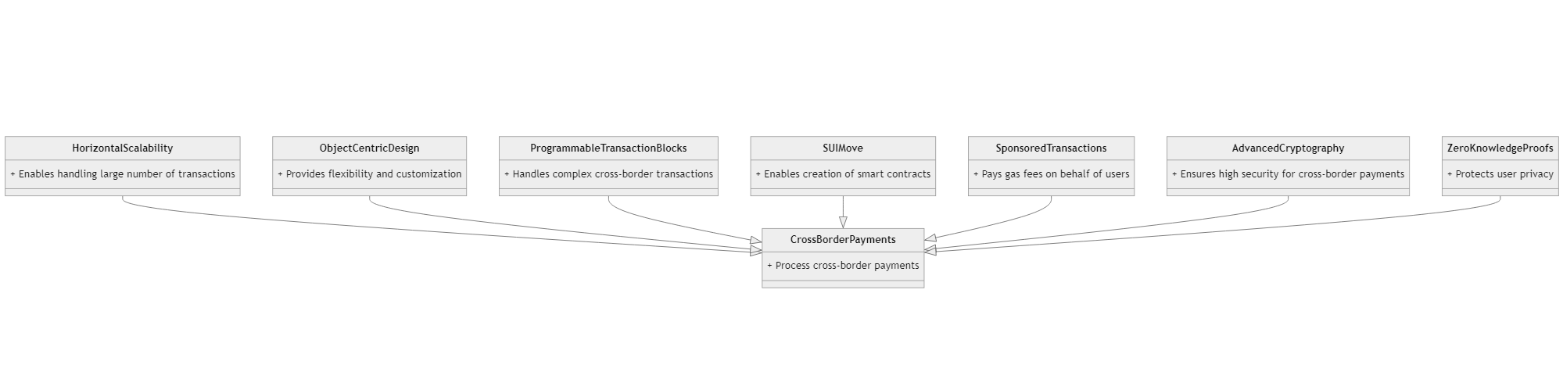

## 

## Marketing and Sales Strategy

Our marketing and sales strategy will focus on building awareness of our platform among potential customers in the cross-border payments market. Our approach will be multi-faceted, leveraging a combination of digital marketing, partnerships, and industry events to reach our target audience.

### Digital Marketing:

We will employ a variety of digital marketing channels to reach potential customers, including social media, search engine advertising, and content marketing. Our content marketing strategy will focus on producing high-quality thought leadership content that showcases our expertise in the cross-border payments space and highlights the benefits of our platform. We will also use social media platforms, such as Twitter and LinkedIn, to engage with our target audience and share updates on our platform's features and functionality.

### Partnerships:

We will seek out strategic partnerships with Fintech companies and financial institutions to expand our reach and accelerate adoption of our platform (be those liquidity providers, exchanges, banks or other PSPs). We will target companies that complement our platform's capabilities and offer complementary services to our target customers.

### Industry Events:

We will participate in key industry events, such as conferences and trade shows, to network with potential customers and partners, showcase our platform's capabilities, and stay up-to-date on industry trends and developments.

### Sales Strategy:

Our sales strategy will focus on building relationships with potential customers and demonstrating the value of our platform. We will employ a consultative sales approach, where we work closely with potential customers to understand their specific pain points and requirements and provide customized solutions that meet their needs.

Additionally, we will target financial institutions with our platform's native support of OpenID Connect, which allows regulated institutions to comply with regulations around identity and access management. This feature is a key differentiator for us and will be a major selling point for financial institutions that require fast and secure cross-border payment services.

We will also emphasize the problem of pre funded accounts for financial institutions, highlighting our platform's ability to eliminate the need for them by enabling instant and low-cost cross-border transactions.



## 

## Operations and Management

Our company will require a highly efficient and streamlined operational model to ensure that we can provide our customers with the best possible service. To achieve this, we will adopt a decentralized operational model with a strong focus on automation and process optimization. Our team will be composed of highly skilled professionals with experience in payments and a deep understanding of blockchain technology.

The key operational functions of our business will include customer support, technology development, marketing, and compliance. We will leverage advanced customer service tools, such as chatbots and automated email responses, to provide quick and efficient customer support. Our technology development team will work to continually improve our platform, ensuring that we stay at the forefront of the cross-border payment industry.

We must not undervalue the mechanics of instrument management and liquidity (which proved to be a significant scaling barrier for other initiatives). Either the project is destined to the ecosystem dilemma and requires micromanaging the cash flows, or it depends on outside factors and incurs risks as a result. Thus, we aim to answer these with the following:

1. Customized Currency as a Service: We will offer a tailored currency service per channel, leveraging the existing infrastructure and desire of banking institutions to recognize the value representation. This approach eliminates the immediate need to introduce the exchange medium to the retail market, ensuring a smoother adoption process.
2. Development of SFSP's Own Token: We will gradually introduce our own token, implementing a controlled and gradual release to maintain stability and avoid undue pressure on the market. This approach ensures a sustainable and secure ecosystem.
3. Utilization of External High-Liquidity Tokens: To further enhance liquidity, we will explore the utilization of external high-liquidity tokens. This may require the establishment of a specialized trading department dedicated to driving down associated costs and optimizing transaction frequency and volume.

Compliance is a crucial aspect of our business, given the highly regulated nature of the cross-border payment industry. Due to this, we are avoiding company registration before receiving help from the accelerators, as opening an entity of this kind requires specific reguatory pre-approvals available after an MVP. We will ensure that our platform is fully compliant with all relevant regulations, including anti-money laundering (AML) and know your customer (KYC) regulations. We will also maintain strong relationships with regulatory bodies to ensure that we stay up-to-date with any changes to regulations that may impact our operations. Considering the intellectual property aspect, we expect considerable patent activity to unfold at several stages: a surface initial patent in during the two quarters and waves of more detailed patent applications in Year 3 and beyond.

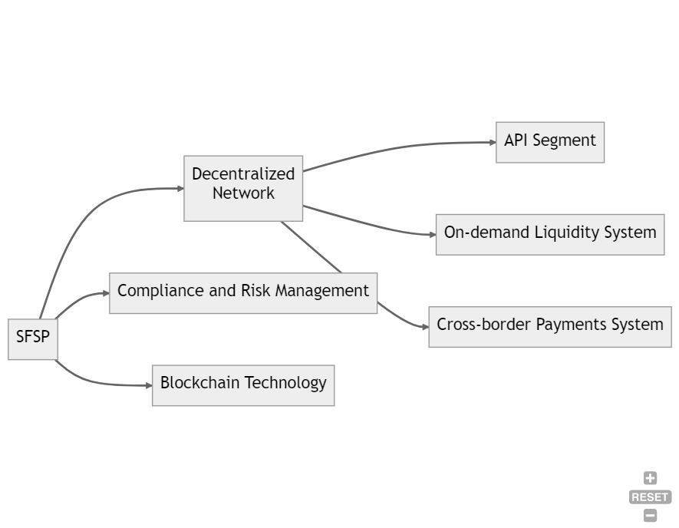

### 

### 

### 

### Organisational Structure:

Our company will operate with a flat organizational structure, with a focus on cross-functional collaboration and agile decision-making. We believe that this structure will enable us to respond quickly to changing market conditions and customer needs especially in the view of [increasing](https://hotbit.zendesk.com/hc/en-us/articles/14750194236823) regulatory [pressures](https://www.reuters.com/technology/eu-states-approve-worlds-first-comprehensive-crypto-rules-2023-05-16/) and public scrutiny over [decentralisation](https://www.coindesk.com/business/2023/03/01/crypto-long-short-decentralized-exchange-research-ramps-up/).

The following is an overview of the key roles and responsibilities[10] within our company:

1. Founder/CEO: The founder/CEO will be responsible for setting the overall strategic direction of the company, raising capital, and building a strong team. They will also oversee all major decisions related to the company's operations and finances.
2. Chief Operating Officer: The COO will be responsible for overseeing day-to-day operations, including product development, customer support, and marketing. They will work closely with the CEO to ensure that the company is meeting its goals and objectives.
3. Chief Technology Officer: The CTO will be responsible for overseeing the development and maintenance of our technological infrastructure. They will work closely with the CEO and COO to ensure that our platform is secure, scalable, and efficient.
4. Chief Financial Officer: The CFO will be responsible for overseeing all financial aspects of the company, including budgeting, financial reporting, and investor relations. They will work closely with the CEO and COO to ensure that the company's finances are well-managed and that we are meeting our financial goals.
5. Head of Sales: Will be responsible for developing and implementing our sales strategy, including identifying new potential customers and closing deals. They will work closely with the CEO and COO to ensure that our sales efforts are aligned with our overall business goals.
6. Head of Customer Sales: Will be responsible for ensuring that our customers are satisfied with our platform and services. They will work closely with the Head of Sales and COO to ensure that our customers' needs are being met and that we are providing a high level of customer support.
7. Head of ComplianceHead of Compliance: Will be responsible for ensuring that our company is compliant with all relevant legal and regulatory requirements. They will work closely with the CEO and CFO to ensure that we are operating in a compliant manner and that our compliance program is up-to-date and effective.
8. Chief Programming Officer: Will be responsible for overseeing the development and implementation of our company's software and technology solutions. They will work closely with the CEO and CTO to ensure that our technology is cutting-edge, efficient, and meets the needs of our clients. Additionally, the Chief Programming Officer will be responsible for managing the programming team and ensuring that our technology is developed and implemented in a timely and effective manner.



## Financial Projections

### 

### Project Milestones:

### Year 1:

Q1-Q2: The company will develop a comprehensive business plan and seek grant funding to support the initial stage of operations. The target amount for the quarter is approximately $500,000. These funds will be allocated towards:

1. Talent acquisition ($300,000)
2. Technology infrastructure ($100,000)
3. Compliance efforts ($50,000)
4. Operational expenses ($50,000).

The company will pursue applications to prominent startup accelerators and incubators, aiming to secure a position in these programs. This will provide access to valuable mentorship, guidance, and potential funding opportunities to refine the business strategy and establish meaningful connections within the financial sector. The team will start building the platform.

Q3: The company will secure a significant investment of $500,000 in a funding round led by angels. This injection of capital will allow the company to accelerate its growth plans, expand the development team, and expedite the platform's roadmap. The team will sign up contracts with market makers/network banks to solve one of the main challenges of the project - increase liquidity.

Q4: The company will assemble a diverse and skilled team of professionals, including developers, designers, and compliance experts. Their expertise will support the development of the platform's initial version, with a strong emphasis on core functionality and seamless integration capabilities.

### 

### Year 2:

Q1: The company will target securing Series A funding of $1,400,000[11] from reputable venture capital firms to further accelerate growth. This additional funding will be allocated towards enhancing the platform's performance, scalability, and security measures.

1. Salaries: $780,000 overall, with $180,000 allocated for the salaries of two new programmers and one marketologist who will help us scale our business.
2. Marketing: $200,000 to help us increase our brand awareness and reach more potential customers.
3. Compliance expenses: $100,000 to ensure that our operations remain compliant with all relevant legal and regulatory requirements.
4. Technological infrastructure: $150,000 to invest in the technological infrastructure required to support our growth.
5. Operational expenses: $70,000 to cover the day-to-day costs of running our business.

Q2: The company will continue platform development and conduct rigorous beta testing with a diverse range of financial institutions. The insights gained from this testing phase will inform refinements, addressing any identified issues or challenges to optimize the platform's functionality.

Q3: The company will publicly launch the platform and actively onboard a substantial number of financial institutions. The target is to establish 10 active partnerships, leveraging additional functionalities such as advanced analytics and reporting tools to deliver added value to users.

Q4: The company will conduct regular performance reviews and user satisfaction surveys to assess the effectiveness of the platform. Based on feedback and market trends, the focus will be on technical achievements, including transaction speed optimisation enhanced security measures and expanded compatibility with present payment systems.

### Year 3:

Q1-Q2: The company will prioritize expanding the platform's user base by targeting regional and international financial institutions. Strengthening relationships with existing partners and exploring new market opportunities will drive increased adoption.

The company will actively seek additional funding rounds, aiming to secure $3,000,000 to support scalability and pursue strategic partnerships or acquisitions. These endeavors will expand the company's market reach and facilitate the enhancement of the platform's capabilities.

1. Salaries: $1,380,000 overall, with $350,000 allocated for the salaries of five new programmers, two compliance officers, two marketologists, and three operations personnel who will help us scale our business.
2. Marketing: $400,000 to help us increase our brand awareness and reach more potential customers.
3. Compliance expenses: $200,000 to ensure that our operations remain compliant with all relevant legal and regulatory requirements.
4. Technological infrastructure: $400,000 to invest in the technological infrastructure required to support our growth.
5. Operational expenses: $100,000 to cover the day-to-day costs of running our business.

Q3: The company will focus on:

1. Continuous improvement of the platform's user experience
2. Emphasizing streamlinedonboarding processes (estimated duration 1-3 months on average)
3. Improved customer support
4. Iterative product updates based on user feedback
5. Signing new partnership agreements with market makers and financial institutions
6. Retaining current customers and partners

Q4: The company will conduct comprehensive audits of the platform's compliance with industry standards, including ISO27001 ISO27701 and SOC Type 1 and Type 2. Demonstrating a commitment to security, data privacy, and regulatory compliance will reinforce the company's reputation.

The company's ability to secure investments will play a crucial role in achieving its milestones and realizing its vision in the cross-border payments market.

### 

### The company will have three revenue streams:

1. Integration Fee: Financial institutions that want to integrate with the platform will be charged a one-time subscription fee based on the complexity of the integration process. The fee will range from $50,000 to $250,000. Therefore, the estimated average Subscription Fee for 1 bank is: ($50,000 + $250,000) / 2 = $150,000.
2. Network Access Fee: Once financial institutions are integrated into the platform, they will be required to pay a recurring fee for network access. The fee will be based on the volume of transactions processed and will range from $5,000 to $25,000 per month. Therefore, the estimated average Recurring Fee for 1 bank is: ($5,000 + $25,000) / 2 = $15,000.
3. Transaction Fee: The platform will charge a transaction fee of 0.4% of the total transaction value for every cross-border transaction conducted in SFSP’s native token[12]. The fee will be shared between the company and its network partners. The estimated average Transaction Fee for 1 bank is calculated on the tree diagram below.

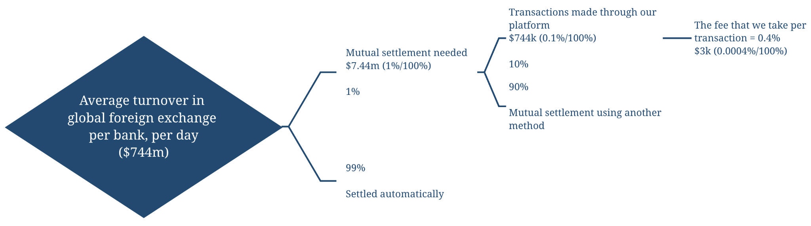

The estimated average revenue for 3 years is calculated on the tree diagram below.

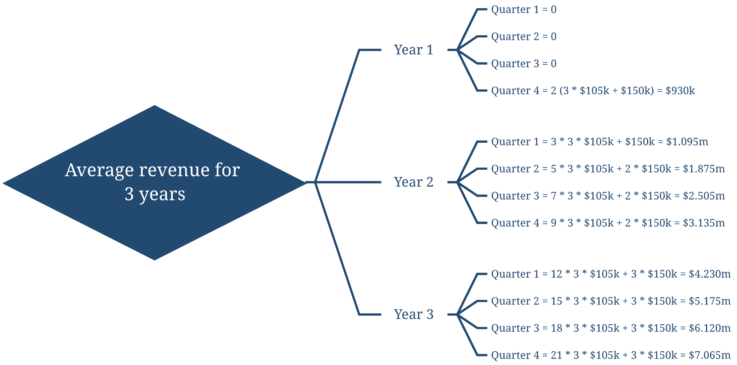

### The key assumptions for the financial projections are:

1. The number of financial institutions onboarded will increase steadily over the three-year period, as the platform gains more recognition in the market.
2. The transaction volume per institution will also increase as the platform becomes more established, and as more financial institutions are integrated into the platform.
3. The subscription fee for integration and the recurring network access fee will remain consistent throughout the three-year period.
4. The transaction fee of 0.4% will remain consistent throughout the three-year period.
5. The operating expenses will increase gradually over the three-year period, in line with the growth of the platform.

Overall, the financial projections demonstrate a strong potential for growth, with a significant increase in revenues expected over the three-year period. The projections also highlight the importance of building a large network of financial institutions to ensure a steady and consistent revenue stream from transaction fees. We will also need to be proactive in monitoring and responding to industry trends and developments, as well as regulatory changes that may impact our business.

To manage our finances effectively, we will implement a rigorous budgeting and forecasting process, regularly reviewing and adjusting our projections based on our actual performance. We will also invest in research and development to ensure that our platform remains at the forefront of technological advancements in the payments industry.

In terms of risk management, we will prioritize security and compliance, implementing robust measures to protect our customers' data and prevent fraud. This incorporates an adequate level of insurance coverage to pre-empt any unforeseen events.

## Legal and Regulatory Considerations:

As a PSP operating in the cross-border payments market, our company will be subject to a range of legal and regulatory requirements at both national and international levels. To ensure compliance with these requirements, we will establish a robust legal and regulatory framework.

In Europe, the company will need to comply with three major pieces of regulations:

1. [General Data Protection Regulation](https://gdpr-info.eu/) GDPR
2. [Payment Services Directive 2](https://www.eba.europa.eu/regulation-and-policy/single-rulebook/interactive-single-rulebook/5402) PSD2
3. [The Markets in Cryptoassets](https://www.europarl.europa.eu/doceo/document/TA-9-2023-0117_EN.pdf) MiCA

Other important legal and regulatory considerations for our company include:

1. IP protection: We will need to protect our intellectual property, including our platform, software, and other proprietary technology, through patents, trademarks, and other means.
2. Contractual agreements: We will need to enter into contractual agreements with our partners, customers, and vendors that include appropriate terms and conditions to ensure compliance with relevant regulations.
3. Data privacy and cybersecurity: We will need to ensure that our platform and data management practices comply with other local data privacy and cybersecurity regulations
4. Passed-down depositor funds regulations

We will carefully collaborate with legal counsel and regulatory specialists to develop policies and processes that adhere to all pertinent rules in order to solve these legal and regulatory concerns. As regulatory requirements change, we'll also periodically examine and adapt our compliance programme to guarantee continued compliance. Further, in order to guarantee that our platform and services are created with compliance in mind, we will include legal and regulatory issues into the product development process.



## Technological Considerations:

### 

### Tech Stack

Technological infrastructure is a critical aspect of any novel payment company's success. Our cross-border payments market platform must be secure, reliable, and scalable. To achieve this, we will rely on a range of:

1. Programming languages such as Python, Golang, Rust, SUI Move, and C++.
2. Web technologies such as JavaScript, TypeScript, HTML5, CSS3, React, jQuery, Ruby, PHP, Smarty, and Modernizr. These technologies will enable us to create user-friendly and responsive web pages that will be accessible on a range of devices.
3. Infrastructure support platforms including Docker and Kubernetes, which will enable us to automate our deployment processes and ensure that our platform is highly available. We will also rely on NGINX, Amazon S3, Amazon EC2, Redis, Kafka, and RabbitMQ to support our platform's infrastructure. These technologies will enable us to build a highly available and scalable infrastructure that can support the needs of our growing user base.
4. General tools and platforms such as CloudFlare, Slack, WordPress, Jira, G Suite, and Confluence. These tools and platforms will enable us to collaborate effectively, manage our projects efficiently, and ensure that our platform is always up-to-date.

### 

### 

### Process Standards:

To ensure the security and reliability of our platform, we will conduct regular standard checks and audits. The ISO27001 standard will help us to identify and manage risks to our platform's security. We will also implement ISO27701 guidelines to ensure the privacy of our customers' personal data. Penetration testing will be regularly conducted to identify vulnerabilities in our platform and address them before they can be exploited by malicious actors.

We will also conduct SOC 1 Type 1 and Type 2 audits to ensure that our platform's internal controls are effective in achieving our financial reporting objectives. Similarly, we will conduct SOC 2 Type 1 and Type 2 audits to ensure that our platform's information security controls are effective in protecting the confidentiality, integrity, and availability of our customers' data. These audits will enable us to continuously improve our platform's security and reliability, which will be critical to the success of our business.

In addition to these standards and audits, we will also implement a range of other security measures to ensure the security and reliability of our platform.

These measures will include:

1. Multi-factor authentication
2. Role management
3. Encryption: All data transmitted between our platform and our customers' devices will be encrypted using the latest encryption protocols, such as SSL/TLS.
4. Regular backups: We will regularly backup our platform's data to ensure that we can quickly recover from any data loss or system failure.
5. Real-time monitoring: We will use tools such as TrackJS to monitor our platform's performance and detect any issues in real-time, allowing us to quickly respond and resolve any issues.



## Conclusion

SFSP is poised to revolutionize the cross-border payments industry by providing a cutting-edge platform that addresses the challenges faced by international companies and financial institutions.

Our mission is to deliver affordable and scalable solutions that enable financial institutions to embrace digital transformation and optimize their operational efficiency.

With a vision of creating a secure, seamless, and efficient ecosystem for wholesale transactions, SFSP is strategically positioned to capture a significant market share.

Our target customer segments, including other PSPs, banking institutions, international companies, and government-related entities, represent lucrative markets with substantial growth potential.

Through strategic digital marketing partnerships, active participation in industry events, and fostering collaborations with key stakeholders, we will establish a strong market presence and drive widespread adoption of our platform.

The projected revenues of $32.13M over the next three years, generated through subscription fees, recurring fees, and transaction fees, underscore the significant revenue-generating potential of our business model.

Led by our experienced and accomplished management team, we possess the requisite expertise and industry insights to effectively execute our strategy and drive the company's sustainable growth.

To fuel our expansion and gain a competitive edge, we are actively seeking $1M in initial funding, followed by an additional $4.4M over the next two years, to cover operational, marketing, and development expenses.

We invite visionary investors who recognize the disruptive potential of SFSP and share our unwavering commitment to transforming the cross-border payments landscape with blockchain to join us.



1. The Payment Service Providers (PSPs) market is a highly competitive and rapidly evolving industry that provides online merchants and businesses with the tools to process electronic payments. The market is dominated by a few major players, including PayPal Stripe Square Adyen Braintree who offer a range of payment processing solutions, such as credit card processing, mobile payments, and e-wallets. These companies have established a strong foothold in the market by providing reliable and secure payment processing services, along with value-added features such as fraud detection and prevention, subscription billing, and analytics. The PSPs market is expected to continue growing and quite rapidly in the nearest time as more businesses shift towards digital payments and e-commerce transactions
2. This includes: inspirational content driving change, educational content, content exploring industry trends, industry research, opinion
3. For instance, Ripple established a range of agreements with [Peersyst Technology](https://peersyst.com/), a tech startup that brought blockchain to Colombia government systems of land registry
4. According to Allied Market Research
5. According to Grand View Research
6. Global Average Remittance Cost: 7.45% (World Bank, 2017)
7. OpenID Connect (OIDC) is primarily used for user authentication and authorization, which can be important components of a cross-border payment system. For example, OIDC can be used to authenticate users and authorize access to different parts of the payment system based on user roles and permissions. In addition, OIDC can be used to securely exchange user information between different parts of the payment system, such as between a mobile app and a web application. This can help ensure that user data is protected and that transactions are executed only by authorized users. When using OIDC with blockchain technology, the distributed and immutable nature of the blockchain can be leveraged to enhance security and transparency. For example, OIDC can be used to authenticate users and authorize transactions, and the blockchain can be used to record and validate transaction data in a way that is secure and tamper-proof.
8. It should be noted that there may be some preliminary challenges associated with transaction management, given the anticipated issues with liquidity availability in certain directions. As such, prudent planning will be imperative, alongside the promotion and expansion of retail trading and other potential use cases, which can be facilitated by utilizing multiple payment rails.
9. Although some of these are not incorporated into immediate mechanics, they are very likely to shape SFSP’s concept at lateral stages
10. As of this moment only a small share of outlined roles are fulfilled and are currently combined by founders
11. Please note that the requested amount is higher than estimated costs for the sake of prudence
12. This rate may vary for transactions conducted in custom transaction channel token or external tokens (expected to be higher)